**Cash Flow and Present Value for a new loan with below variables –**

age <- 0

funded_amount <- 12000

term <- 60

interest_rate <- 0.0993

discount_rate <- 0.05

loss_given_default <- 0.905

servicing_charge <- 0.015

prepay_rate (for every payment month) <- 0.0076,0.0092,0.0092,0.0093,0.0093,0.0093,0.0093,0.0093,0.0093,0.0093,0.0093,0.0093,0.0092,0.0092,0.0091,0.009,0.0089,0.0088,0.0087,0.0086,0.0085,0.0084,0.0082,0.0081,0.0079,0.0077,0.0076,0.0074,0.0072,0.007,0.0068,0.0066,0.0064,0.0062,0.006,0.0057,0.0055,0.0053,0.005,0.0048,0.0046,0.0043,0.0041,0.0038,0.0035,0.0033,0.003,0.0028,0.0025,0.0023,0.002,0.0018,0.0016,0.0013,0.0011,0.0008,0.0006,0.0004,0.0002,0

default_rate (for every payment month) <- 0,0,0,0.0001,0.0002,0.0005,0.0009,0.0013,0.0017,0.0021,0.0025,0.0028,0.003,0.0032,0.0033,0.0033,0.0033,0.0033,0.0032,0.0031,0.003,0.0029,0.0027,0.0026,0.0025,0.0023,0.0022,0.002,0.0019,0.0017,0.0016,0.0015,0.0014,0.0013,0.0012,0.0011,0.001,0.0009,0.0008,0.0007,0.0007,0.0006,0.0006,0.0005,0.0005,0.0004,0.0004,0.0003,0.0003,0.0003,0.0002,0.0002,0.0002,0.0002,0.0001,0.0001,0.0001,0.0001,0.0001,0

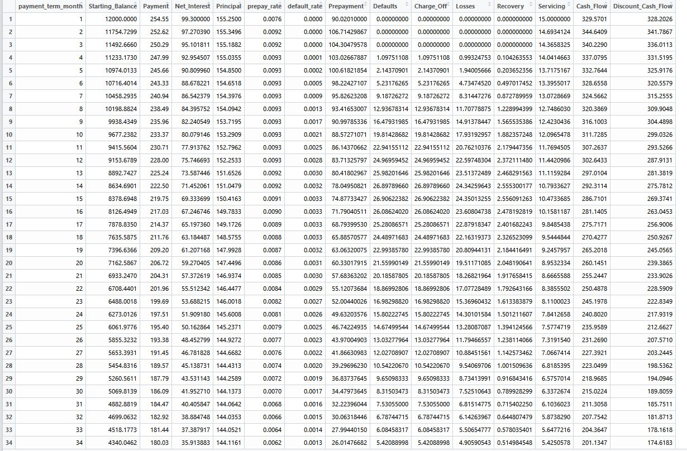

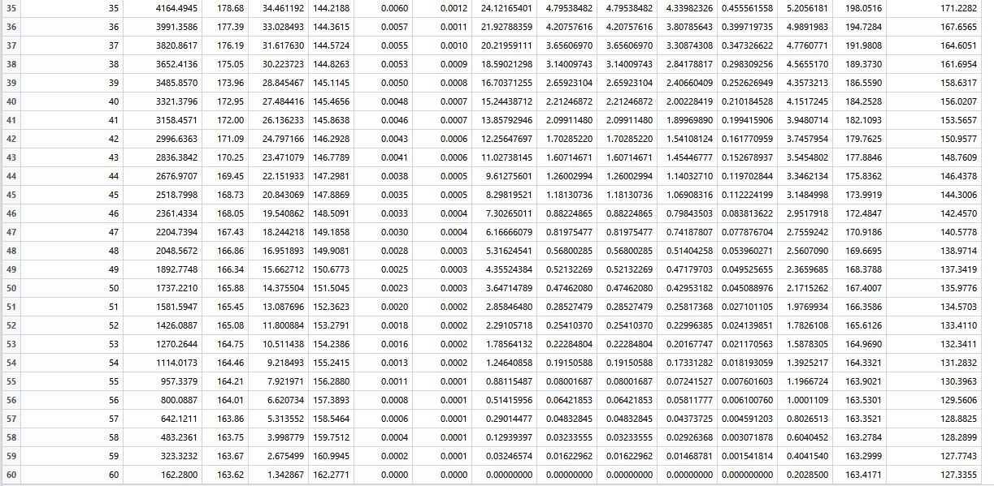



**Cash Flow and Present Value for an aged loan with below variables –**

age <- 26

funded_amount <- 13000

payoff_amount <- 8364.49

term <- 60

interest_rate <- 0.1229

discount_rate <- 0.04

loss_given_default <- 0.905

servicing_charge <- 0.015

prepay_rate (for every payment month) <-0.007,0.0069,0.0067,0.0065,0.0063,0.0062,0.006,0.0058,0.0056,0.0054,0.0051,0.0049,0.0047,0.0045,0.0043,0.0041,0.0038,0.0036,0.0034,0.0031,0.0029,0.0027,0.0024,0.0022,0.002,0.0017,0.0015,0.0013,0.0011,0.0008,0.0006,0.0004,0.0002,0)

default_rate (for every payment month) <- 0.0036,0.0034,0.0032,0.003,0.0028,0.0026,0.0025,0.0023,0.0021,0.002,0.0019,0.0017,0.0016,0.0015,0.0014,0.0013,0.0012,0.0011,0.001,0.0009,0.0008,0.0007,0.0007,0.0006,0.0005,0.0005,0.0004,0.0004,0.0003,0.0003,0.0002,0.0002,0.0002,0.0001

